Create the DNA building blocks
Visual instructions are on second and third pages

Step 1: Cut out Rectangles
Make sixteen 2 by 4-inch rectangles from paper. This can be done by overlaying the 4 sheets of paper (two sheets of one color and two sheets of another color if possible) to form a stack and then cutting out the rectangle. Cut out multiple rectangles from the stack till 16 total rectangles are made.

Step 2: Make the Letters or Bases
Stake the shapes into two groups of 8. Then cut out the shapes of one group in the manner described in Step 2a (Page 3) and cut the other shapes according to Step 2b (Page 4), which will produce 4 different shapes. Then label each shape with Crayon or Marker as A,C,G,T following the picture below. At the end of this step there should be 8 A, 8 C, 8 G, and 8 T shapes.

Step 3: Make the BackBone
Cut out two 10 by 2 inch rectangles.

Step 4: Creating Sequences
Sequence 0: ACGT
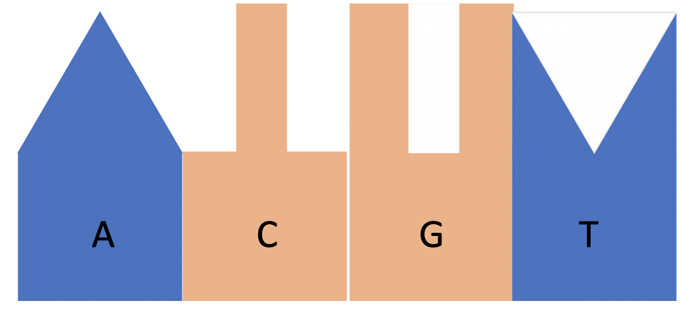
Tape or glue together shapes in the following patterns, following the example to the right for sequences 1-4.
Sequence 1: ACTGC
Sequence 2: AGTGC
Sequence 3: GATTC
Sequence 4: ACGC

Make sure to keep all extra bases and backbone pieces because they will be used for the Virtual Lesson.

Step 5: Done
You are now ready for our lesson!

Visual Instructions
Step 1
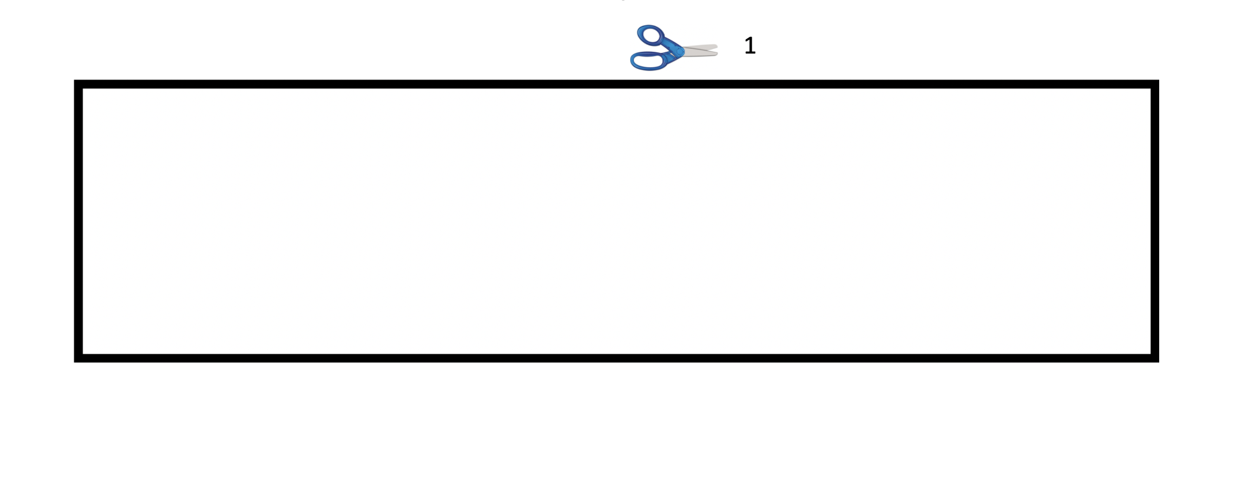
Step 2a
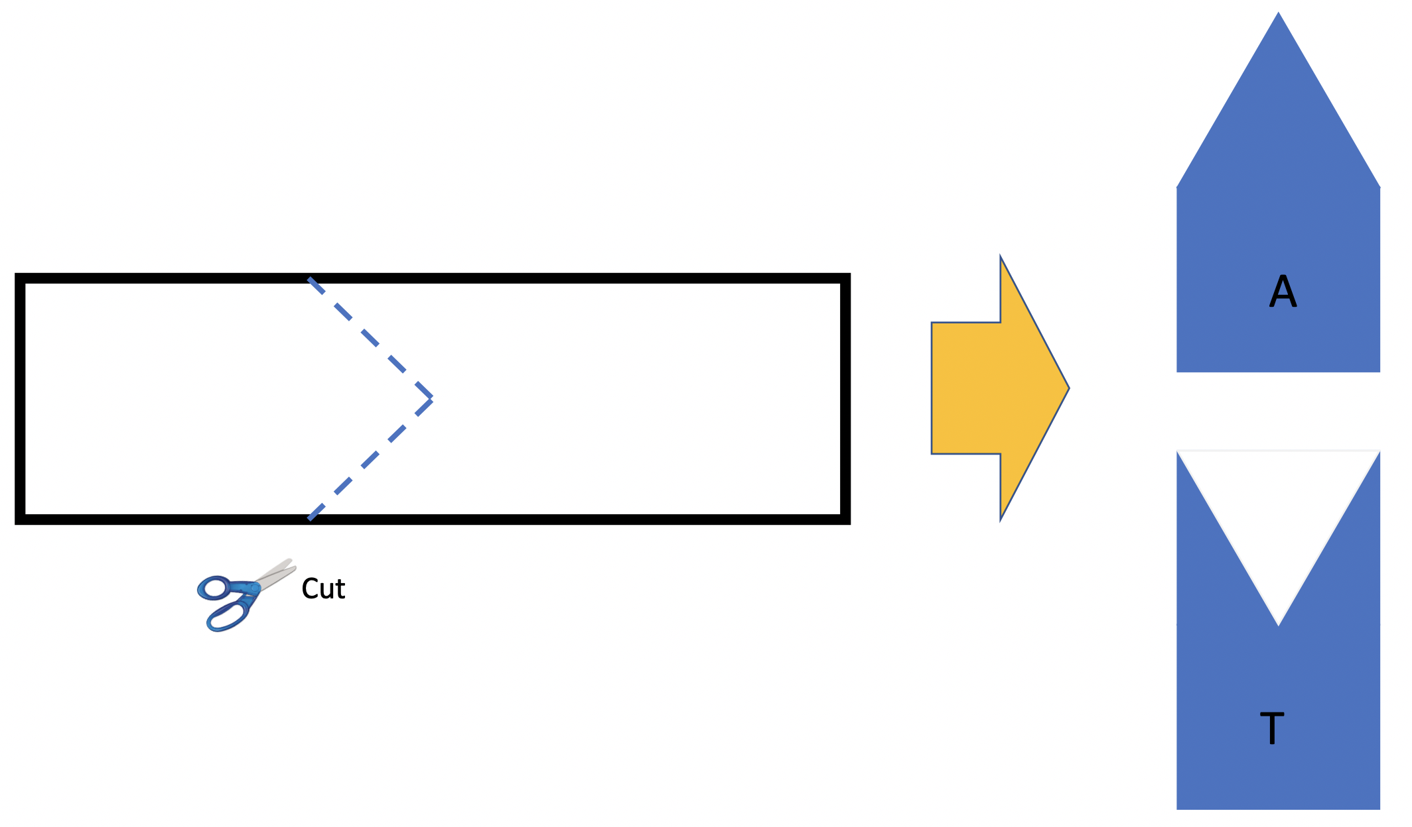

Step 2b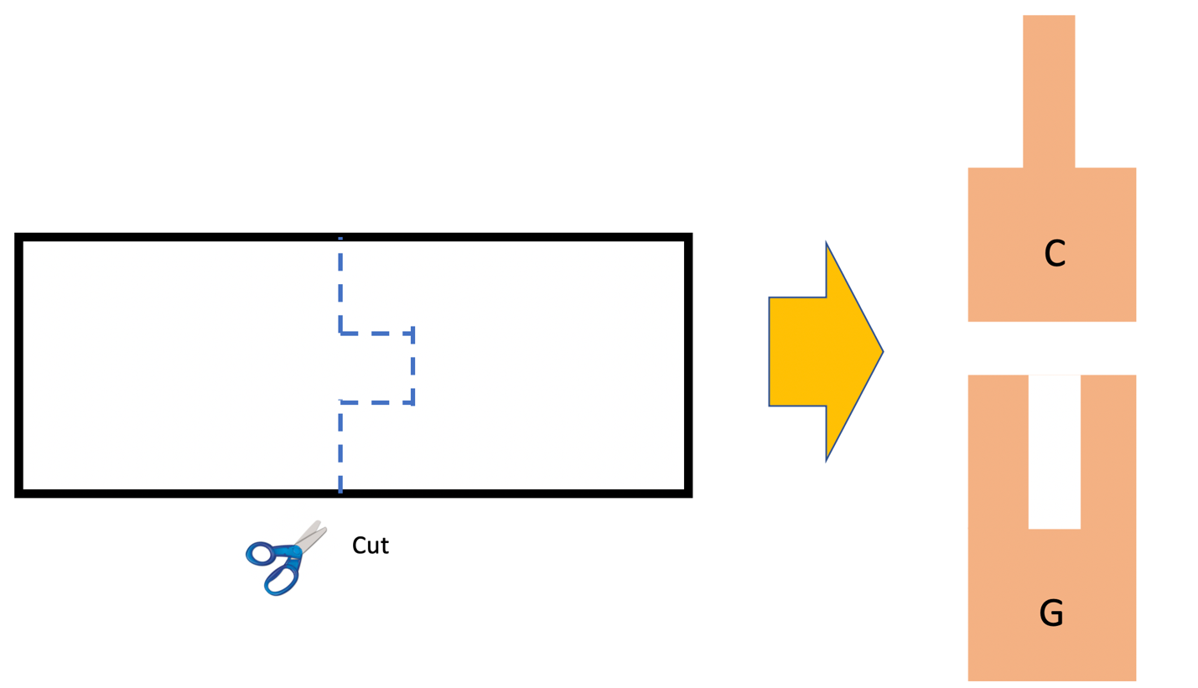
Final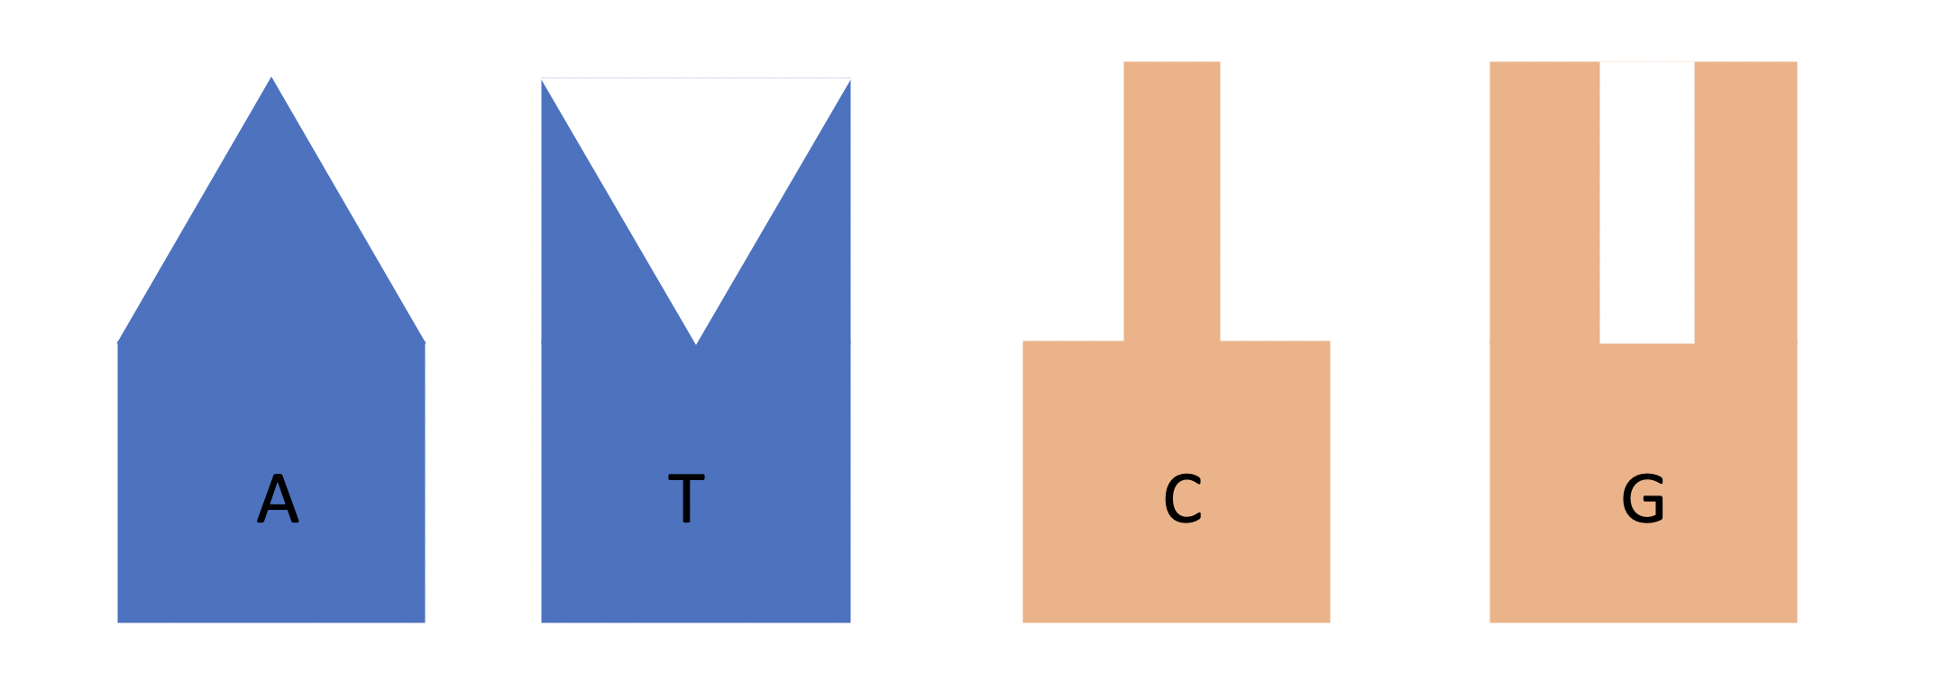
DNA Backbone

