SCRUB FORM DIRECTIONS
Please fill out the scrub from with
- Name
- PIN (you create this number)
- Select Resident or Student
- Size needed
You will then need the form signed by Education staff. You can go to the Education office to get your copy signed. (D317.1) You can also get an emailed copy from Lee Arellano (Lee.Arellano@va.gov) or Marrissa Garza (Marrissa.garza@va.gov)
After you’ve gotten a signed copy please take the form to Patient Effects in the basement. No appointment is necessary. Take the main elevators to the basement turn right when you get off the elevators and make the second left, Patient Effects is on the left side.
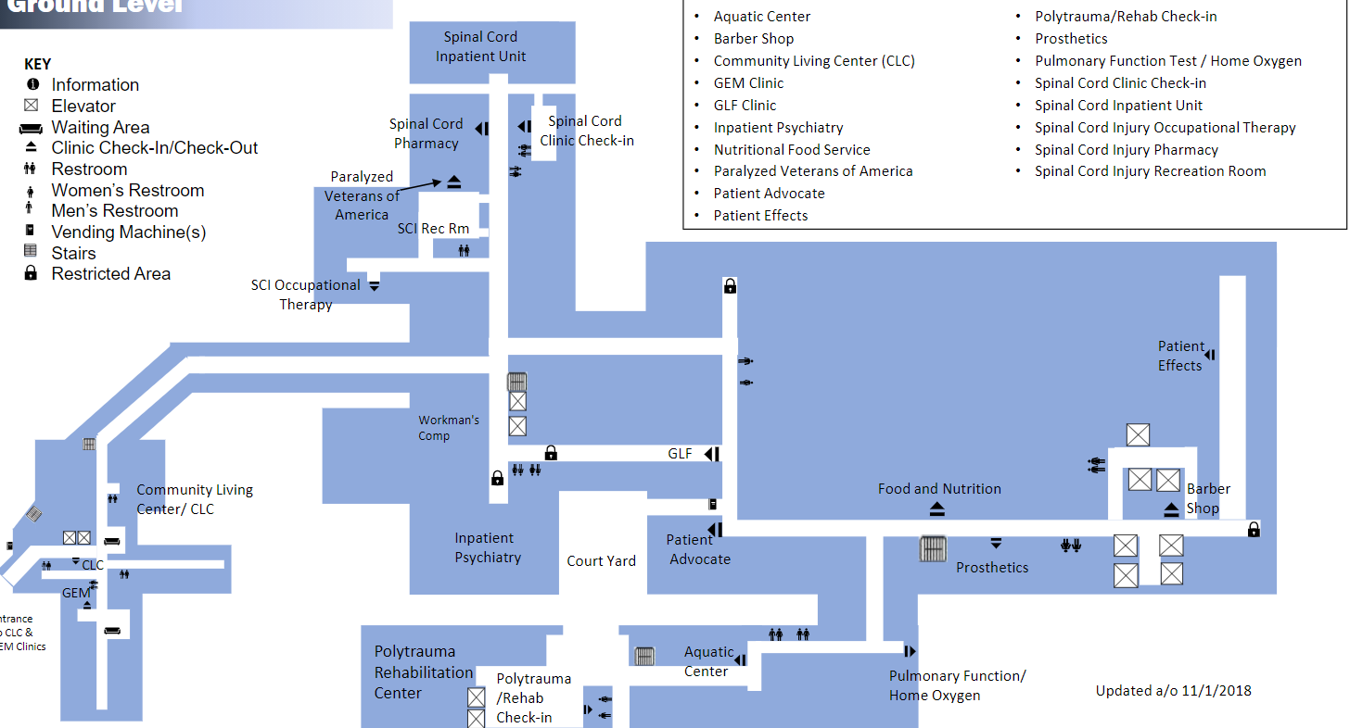
Main Elevators

**Your Scrub card needs to be returned to Patient Effects when you offboard**

