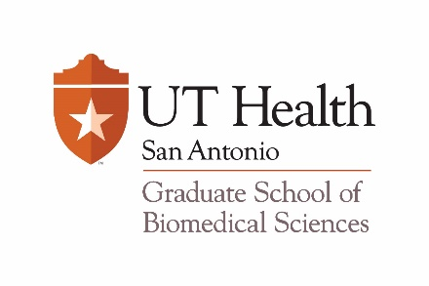
GSBS Travel Award Checklist

Eligibility:
- Students must be enrolled full time in a Doctoral or Master’s Program offered by the Graduate School of Biomedical Sciences.
- Students must be in good academic standing.
- Students must have successfully completed the program qualifying exam and applied for admission to candidacy for the Ph.D. or M.S. degree.
- Students cannot accept multiple travel awards during the same awards season/ for the same conference

Application:
- GSBS Travel Award cover sheet
- CV or Biosketch in NIH format must include all sources of funding the student received (current & past funding)
- One-paragraph statement identifying the benefits to be gained from attending the intended conference and the effects on the student’s career goals
- Unofficial UT Health San Antonio transcript
- Abstract of presentation
- Two letters of recommendation, one of which must be from the Supervising Professor

