- Open any web browser and go to https://remote.uthscsa.edu
- The window below will appear. Under the Issue Submission select “Student Laptop Check” and click the red Submit button.
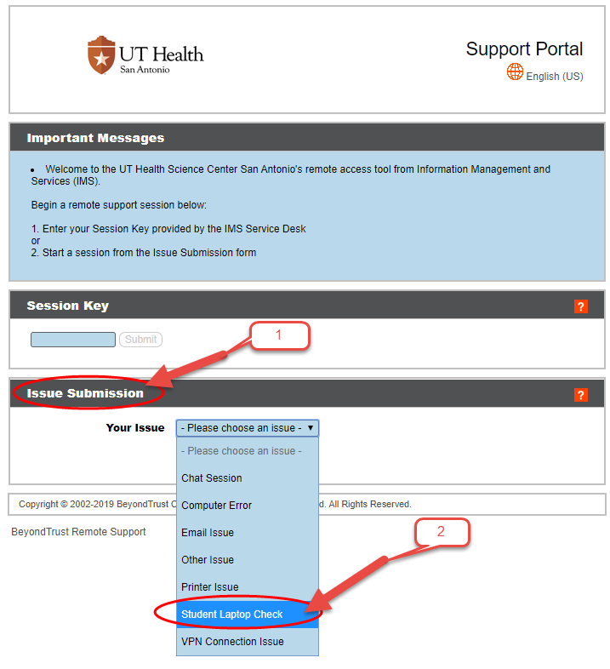
- Next, enter your name and click the Submit button.
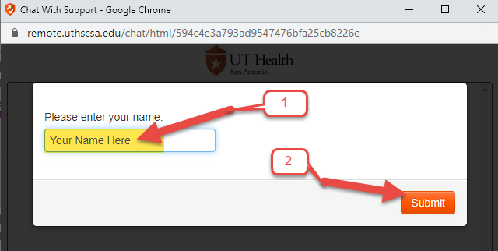
- A new window will appear where you will be able to chat with our service desk staff. A member of our service desk team will then remote into your computer to verify that the computer meets our minimum system requirements for your program.
