Concise Summary – Timeline Tools (Pick any of the below and/or modify as appropriate for your study)

Participation is voluntary. You may choose not to take part in the study or may choose to leave the study at any time without any penalty or loss of benefits to which you are entitled.

About the Research Study
The purpose of this research study is [Type here]

(Provide things to consider before deciding to take part (e.g. intensive time commitments or other study requirements.) [Type here]

Are there any alternatives or other important things to consider?
(List any direct (or indirect) benefits and refer to main consent for more info) [Type here]

What are the benefits to participating?
(List primary, most important risks and refer to main consent for more info) [Type here]

Ex: Your participation will last [days, hours] and will include [number of] visits.
[Type here]
Duration and Procedures
Do I have to participate?
Are there any risks to participating?

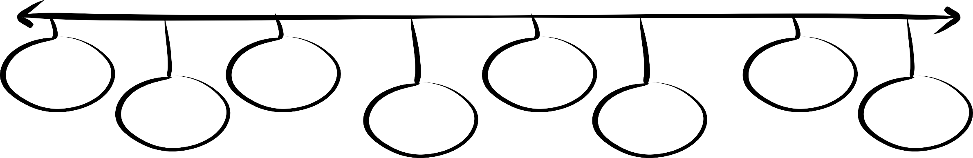
Visit 7
[Type here]
Visit 8
[Type here]
Visit 6
[Type here]
Visit 5
[Type here]
Visit 4
[Type here]
Visit 3
[Type here]
Visit 2
[Type here]
Visit 1
[Type here]
Details of Visit 6
[Type here]
Details of Visit 8
[Type here]
Details of Visit 7
[Type here]
Details of Visit 5
[Type here]
Details of Visit 4
[Type here]
Details of Visit 3
[Type here]
Details of Visit 2
[Type here]
Details of Visit 1
[Type here]

- Statement of Research You are being asked to volunteer for a research study. It is up to you whether you choose to participate or not. There will be no penalty or loss of benefits to which you are otherwise entitled if you choose not to participate or discontinue participation.
- Purpose The purpose of this research is ___ [a brief description]
- Duration It is expected that your participation will last ___ [the time commitment]
- Risks The risks or discomforts associated with this research include ___ [a brief description of the foreseeable risks – consider listing the primary risks of being in this study]
- Benefits As a result of your participation, you can anticipate ___ [a brief description of what will occur], or: There is no expected direct benefit to you for taking part in this study.
- Alternatives [only include if this is a therapeutic study and there are other alternatives – if the only other option is to not take part in the study, then omit]
- Procedures and Activities

