Home Program Faculty Registration Hotel Exhibitors

Focus on interprofessional strategies to promote patient-centered care
Learn from experts...featured speakers discuss precision oncology, palliative care, and more Learn how new agents are transforming cancer treatment
Clinical Track...practical strategies for implementing USP800 Guidelines Transitional Trials Track...incorporate novel agents into clinical practice Meet the Experts reception

Target Audience
Join us for this interprofessional continuing education activity designed for Physicians, Hematologists/Oncologists, Nurses, Nurse Practitioners, Physician Assistants, Pharmacists, students and other health care professionals specializing in oncology. This is a continuing education activity and designed to update the educational needs for all attendees.

Learning and Educational Objectives
At the end of this educational activity, the attendee will be able to:

Describe uses of new (novel) oncology agents in the care of patients with cancer Explain how to integrate palliative care into standard cancer care
Identify strategies to comply with USP800 guidelines

Accreditation
The following continuing education will be offered at this conference:

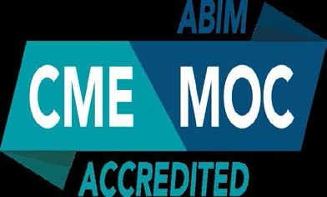
Continuing Medical Education (CME) Maintenance of Certification (MOC) Continuing Nursing Education (CNE) Continuing Pharmacy Education (CPE)

University of Texas Health Science Center at San Antonio is accredited as a provider of continuing nursing education by the American Nurses Credentialing Center's Commission on Accreditation.

The Joe R. & Teresa Lozano Long School of Medicine is accredited by the Accreditation Council for Continuing Medical Education to provide continuing medical education for physicians.

This activity has been approved for AMA PRA Category 1 Credits™.

The American Academy of Physician Assistants (AAPA) and the American Academy of Nurse Practitioners (AANP) accepts certificates of participation for educational activities for AMA PRA Category 1 Credit™ from organizations accredited by the ACCME. Healthcare professionals receiving a certificate of attendance should consult with their licensing board for information on applicability and acceptance.

Successful completion of this CME activity, which includes participation in the evaluation component, enables the participant to earn up to 9.00 MOC points in the American Board of Internal Medicine's (ABIM) Maintenance of Certification (MOC) program. Participants will earn MOC points equivalents to the amount of CME credits claimed for the activity. It is the CME activity provider's responsibility to submit participant completion information to ACCME for the purpose of granting ABIM MOC credit.
This
This event is jointly provided by UT Health Cancer Center, Joe R. & Teresa Lozano Long School of Medicine and UT Health School of Nursing.

Location
This year's conference is being held at the Holiday Inn San Antonio Riverwalk, 217 N. St. Mary's Street, San Antonio, TX 78205.

