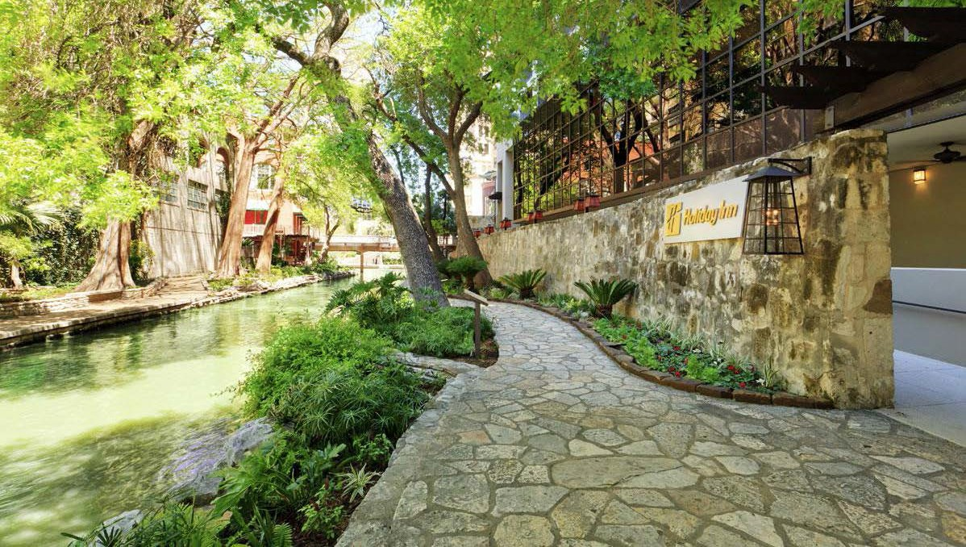

Home Program Faculty Registration Hotel Exhibitors

Holiday Inn San Antonio Riverwalk 217 N. St. Mary's Street
San Antonio, TX 78205 Phone: 210-224-2500
Fax: 210-527-9589

Hotel Reservations
Room reservations can be made at the Holiday Inn San Antonio Riverwalk. The hotel is located in the heart of downtown San Antonio with easy access to the San Antonio Riverwalk. A hotel room rate discount of $159 single/double occupany is being offered during the conference, reference the group code HSC. To learn more about the hotel and to make room reservations click here. Reservations can also be made by calling 210-224- 2500, please use group code HSC.
7979 Wurzbach Road, MSC 8224, San Antonio, Texas 78229, 210.450.1550, Fax 210.150.1560, PANAO@uthscsa.edu

